**Dark Sensor using Transistors**

**Abstract:**

Led will glow according to the light intensity.Whenever there will be minimum(low) light intesnsity the led will glow and when there is maximum light intensity the led will go off.

**Components:**

1. Transistors
2. Resistance(220Ω and 50KΩ)
3. LDR
4. Battery(9v)
5. Led

**About Component:**

* **LDR:**Ldr is light depended resistor when there is no light falling on ldr the resistor decreases so current flow through it.When the light falls on ldr the resistance in that sensor increase hence less current will flow through it.
* **Transistor:** As a switch when a certain rate of current above threshold flows through base the it allows the current to pass from collector to emmiter.When current flows through base is less then it doesn’t allow current to pass from collector to emitter

**Circuit Diagram:**

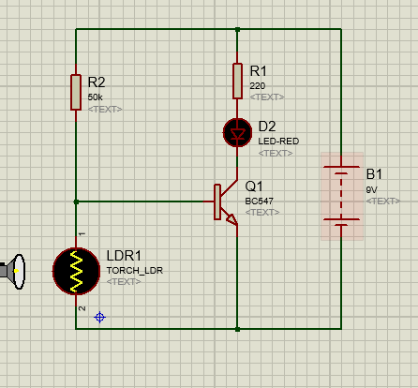

**Working:**

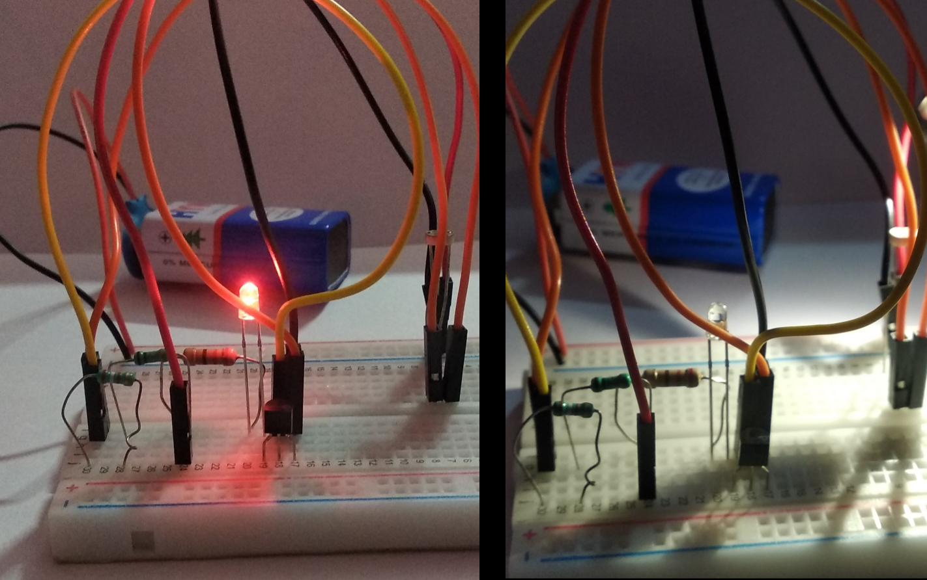

Fig 2.Implementation on Hardware

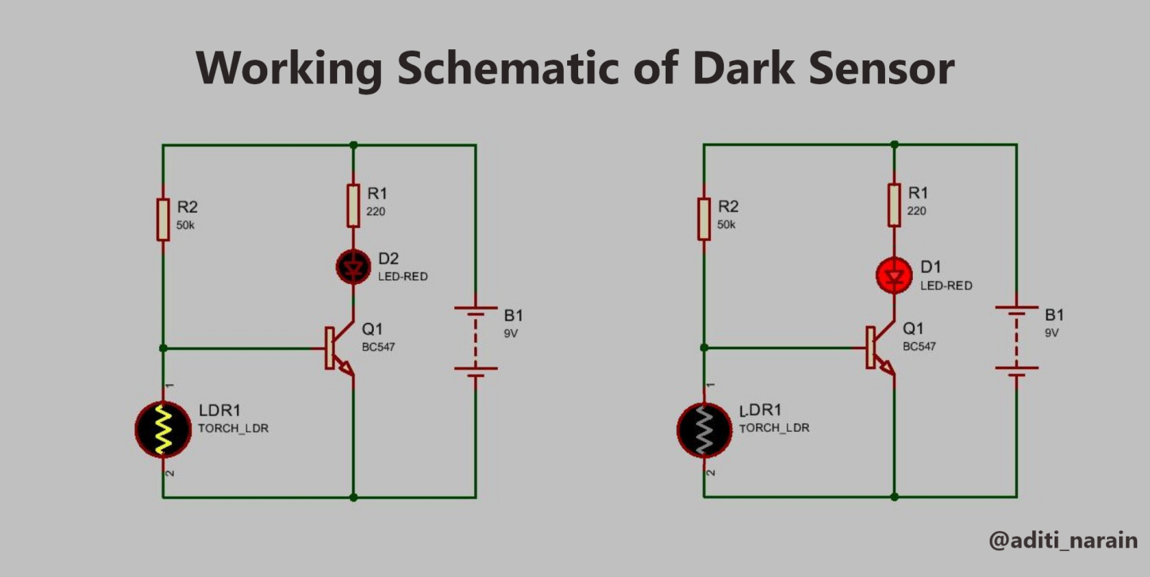

Fig 2.Implementation on Proteus

When current flows from battery

1. There is no light falling on LDR then value of resistance is low so maximum current will flow through that path and very less current will flow from base of transistor. Hence transistor didn’t allow current to flow from collector to emitter (open circuit).

***Conclusion:*** *Led Will Not Glow.*

1. Light falls on led then the resistance in increases so current will flow through the base of transistor. Hence current will start flowing from collector to emitter which closes the circuit (short circuit).

***Conclusion:*** *Led Will Glow.*

**Application:**

1. Night Lamp
2. Automatic Street Light